Case 2-Afr-Egy-Ushabti-Embalmed Mummy-New Kingdom-1600 BCE
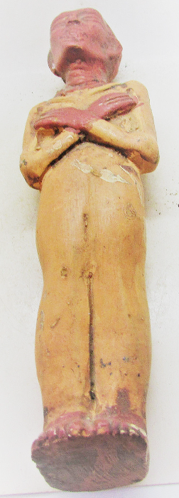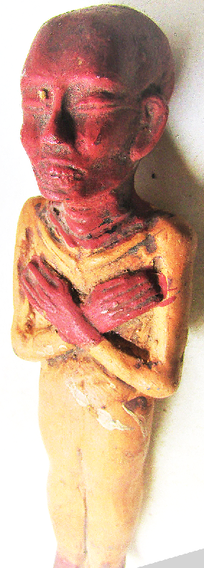
Case no.: 3
Accession Number:
Formal Label:
Display Description:
LC Classification:
Date or Time Horizon:
Geographical Area:
Map:
GPS coordinates:
Cultural Affiliation:
Media:
Dimensions:
Weight:
Condition:
Provenance:
Discussion:
References:

